**The Eco Council invite you to support us by taking part in Earth Hour 2025 as part of our energy project to gain our 4th Eco Schools Award**

Earth Hour 2025 is a time for people all around the world to come together and take action for our planet. **On March 22, 2025, from 8:30 PM to 9:30 PM** in your local time, millions will turn off their lights to show they care about the Earth. This year, Earth Hour is even more important because it aligns with World Water Day, giving us a chance to think about saving energy and water at the same time. Big landmarks like famous buildings and bridges will turn off their lights, and there will be fun events in many places. Earth Hour helps us all think about what we can do to keep the planet healthy. Ready to take part? Let’s make a difference together. Please let us know if you supported us and how, we need the data for our award application. Thank you in anticipation of your support!

1. **Go on a Glow-in-the-Dark Nature Walk:**Take a nighttime walk using glow sticks or lanterns that break down naturally. See how different animals come out at night!
2. **Make Art from Recycled Materials:**Gather friends and family to create art using old or used items. This helps reduce waste while letting you be creative.
3. **Tell Stories by a Bonfire:**Sit around a fire and share stories about nature, the Earth, or your own experiences in the environment.
4. **Take a Break from Screens:**Challenge yourself and your family to go one hour without phones, TVs, or computers. Use the time to talk, play, or enjoy the outdoors.
5. **Look for Nocturnal Animals:**Turn off lights and see what animals come out at night. It’s a great way to learn about wildlife!
6. **Have a Candlelit Dinner:**Cook a meal using local food and eat by candlelight. Talk about ways to make your daily life more Earth-friendly.
7. **Make a Promise Tree:**Set up a tree where people can hang written promises to help the planet, like recycling more or saving water.
8. **Join a Lights-Out Flash Mob:**Plan a surprise event where a group turns off lights at the same time in a public place to show support for saving energy.

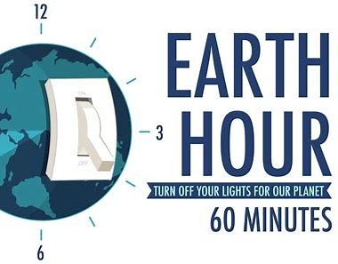These are some to ideas make Earth Hour exciting and encourage people to take care of our planet every day!